***Treasure of the Pyramid***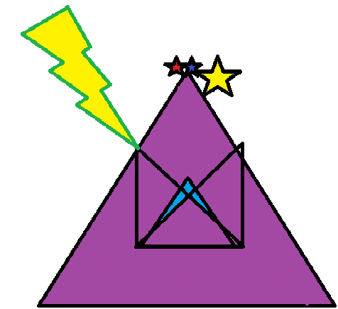

A ***Perpend Stone*** product